Sarit Mizrahi - Game & Frame by Frame Scores
Country: Israel
 | 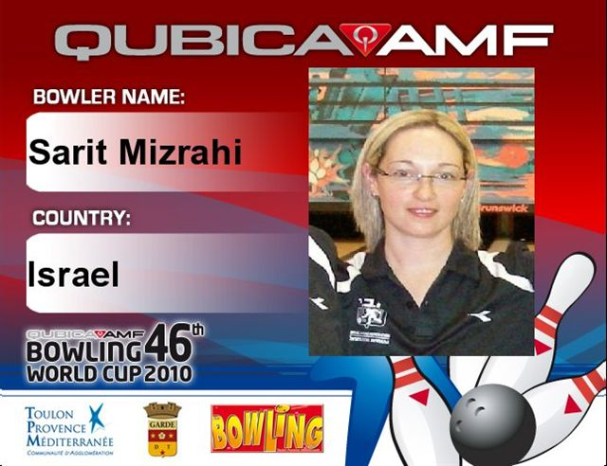
  Game | score
  G1 | 199
  G2 | 235
  G3 | 171
  G4 | 236
  G5 | 180
  G6 | 191
  G7 | 168
  G8 | 188
  G9 | 223
  G10 | 219
  G11 | 205
  G12 | 226
  G13 | 232
  G14 | 195
  G15 | 190
  G16 | 121
  High | Total | Avg | Total inc. bonus
  236 | 3359 | 189.34 | 3359
  Frame by Frame
  Qualifying round (Games 1-5)
  Qualifying round (Games 6-11)
  Qualifying round (Games 12-16)

